Gervasi: Jurnal Pengabdian Kepada Masyarakat

Statement of Originality

I, Hafni Hafsah, hereby agree to publish my/our manuscript entitled Sosialisasi Penggunaan Quizlet Dalam Belajar Kosa Kata Bahasa Inggris Pada Siswa SMKN 2 Pekanbaru in Gervasi: Jurnal Pengabdian Kepada Masyarakat
I declare that the manuscript is my own work and does not contain plagiarism as a whole or in parts.
I acknowledge that the manuscript has not been previously published, nor is it under review or consideration for book chapter or journal publication elsewhere.
I agree to conform to Gervasi: Jurnal Pengabdian Kepada Masyarakat Manuscript Submission Guidelines and that neither during the review nor after acceptance by Gervasi: Jurnal Pengabdian Kepada Masyarakat will I submit the same paper to any other journal.

Pekanbaru, June, 15, 2022
Authors Signatures
1st Author (Hafni Hafsah, S.P., M.Pd) 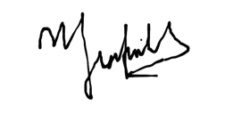 ..............
2nd Author (Full name with title) ....................................
3rd Author (Full name with title) ....................................

