Gervasi: Jurnal Pengabdian Kepada Masyarakat

Statement of Originality

I/We, Nur Amin Barokah Asfari, S.Psi., M.A., hereby agree to publish my/our manuscript entitled Sosialisasi Self-Efficacy Pada Remaja:
Finding The Best Version Of You For Your Better Future in Gervasi: Jurnal Pengabdian Kepada Masyarakat
I/We declare that the manuscript is my/our own work and does not contain plagiarism as a whole or in parts.
I/We acknowledge that the manuscript has not been previously published, nor is it under review or consideration for book chapter or journal publication elsewhere.
I agree to conform to Gervasi: Jurnal Pengabdian Kepada Masyarakat Manuscript Submission Guidelines and that neither during the review nor after acceptance by Gervasi: Jurnal Pengabdian Kepada Masyarakat will I submit the same paper to any other journal.

Malang, January, 13, 2023
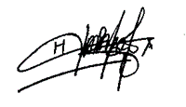
Authors Signatures
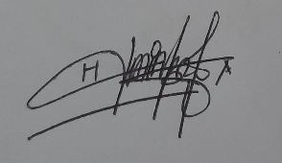
1st Author (Nur Amin Barokah Asfari, S.Psi., M.A.)

